**Explanation of modifications to system calls**

This document will explain the changes done in the kernel source files along with their snippets.

**For open() system call:**

The snippet below shows the main function in open.c file in the /fs directory. This is where the file is accessed. The modification is done to the function name to make a call and return a value(fd).

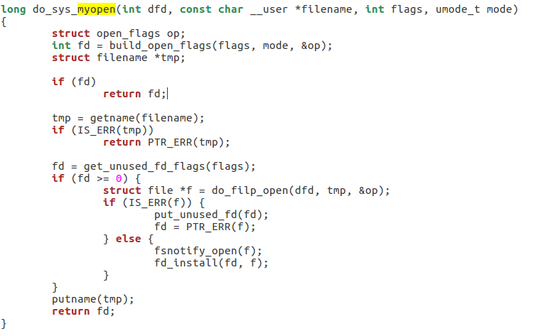

The code below is what calls the function above to open the file. It also displays additional information using printk to the kernel logs when a file is opened.

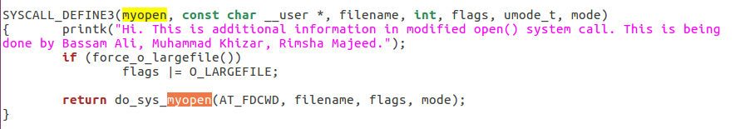

We write the line below in the syscall_64.tbl in the /arch/x86/entry/syscalls directory so that we can use the 335 reference number to make a call to this modified open call when we need to open the file.



This code below is defined in the syscall.h file in the directory /include/linux. It needed to define the modified open calls in the header file so that the kernel registers them while building

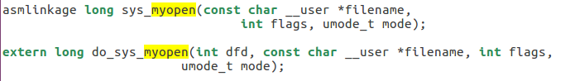

**For close()**

The snippet below shows the main function in file.c file in the /fs directory. This is where the file is accessed. The modification is done to the function name to make a call and close the file after it is used.

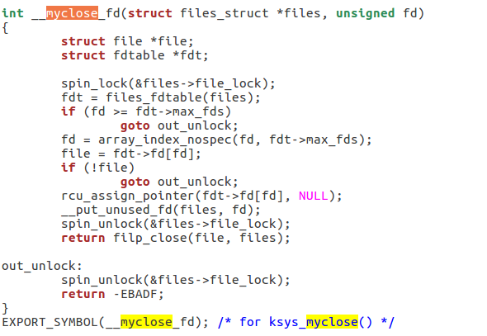

The code below is what calls the function above to close the file. It also displays additional information using printk to the kernel logs when a file is closed.

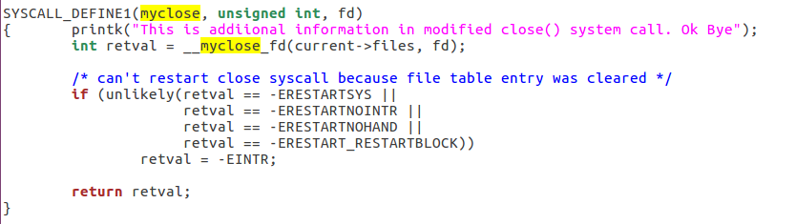

This code below is defined in the syscall.h file in the directory /include/linux. It needed to define the modified close calls in the header file so that the kernel registers them while building



We write the line below in the syscall_64.tbl in the /arch/x86/entry/syscalls directory so that we can use the 336 reference number to make a call to this modified close call when we need to close the file.

